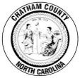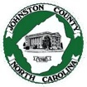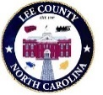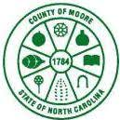
Cape Fear Regional Hazard Mitigation Plan
Public Survey
Announcement

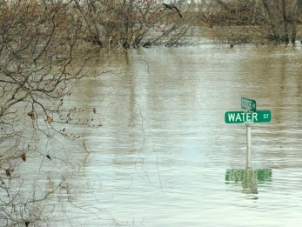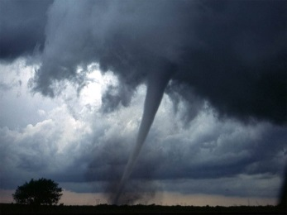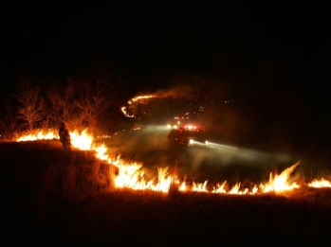
Floods, Wildfires, Tornadoes, Winter Storms, Hurricanes…What Concerns You?
The counites of Cape Fear, in coordination with their participating municipal jurisdictions, are updating the Regional Hazard Mitigation Plan. The Cape Fear Regional Hazard Mitigation Plan identifies local policies and actions for reduction risk and future losses from natural disasters to better protect our community from natural disasters such as:
- Flood
- Wildfires
- Earthquakes
- Hurricanes
- Severe Storms
- And more!

We need your voice to help identify risks, prioritize concerns, and shape strategies to reduce future impacts.
Please take a moment to complete the public survey by clicking the following link or scanning the QR code:
2025 Cape Fear (Chatham, Harnett, Johnston, Lee and Moore) Regional Hazard Mitigation Plan Update Survey



Everyone’s input counts – whether you’re a homeowner, renter, business owner, or student. Thank you for helping us build a safer future together!

If you would like to learn more, please contact one of the following county coordinators for this project:

Scot Brooks, Moore County Emergency Management Steve Newton, Chatham County Emergency Management
910.947.6317/ sbrooks@moorecountync.gov 919.545-8162 / steve.newton@chathamcountync.org

Zach Shean, Harnett County Emergency Management Sandy Wood, Johnston County Emergency Management
910.893.7580 / zshean@harnett.org 919.989.5705 / sandy.wood@johnstonnc.com

Matthew Britt, Lee County Emergency Management
919.718.4670 / mbritt@leecountync.gov

